**Note to Student/Guardian:** We hope you will have fun creating our weekly art lessons. Feel free to **contact your art teacher** with any questions you may have about this lesson. When responding, please include : **Student Name, Grade, Classroom Teacher, Lesson Name.** We would be **happy** to hear from you!

Mr. Jocoy Mrs. Melloni Mr. Johnson

[ajocoy@nfschools.net](mailto:ajocoy@nfschools.net) [amelloni@nfschools.net](mailto:amelloni@nfschools.net) [majohnson@nfschools.net](mailto:majohnson@nfschools.net)

Ms. Ryan Mrs. Brooks

[tryan@nfschools.net](mailto:tryan@nfschools.net) [cbrooks@nfschools.net](mailto:cbrooks@nfschools.net)

**NFCSD Art Educators**

**Grade 2**

***My Favorite Color: Scavenger Hunt***

Supplies: magazines, newspapers, found objects, scissors, glue or glue stick, crayons, markers, paper or tag board or cardboard.

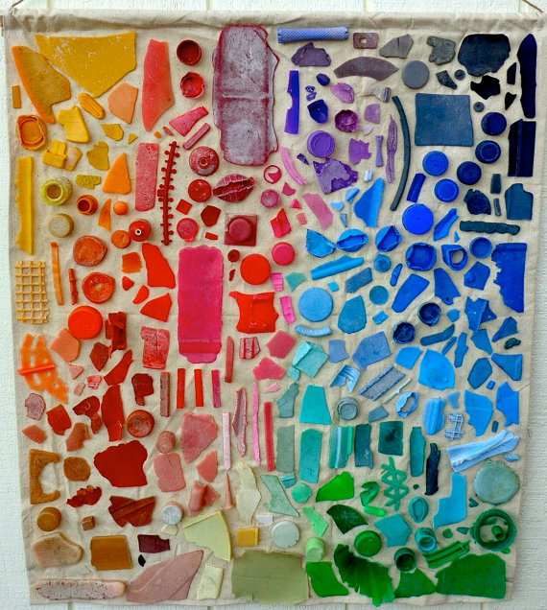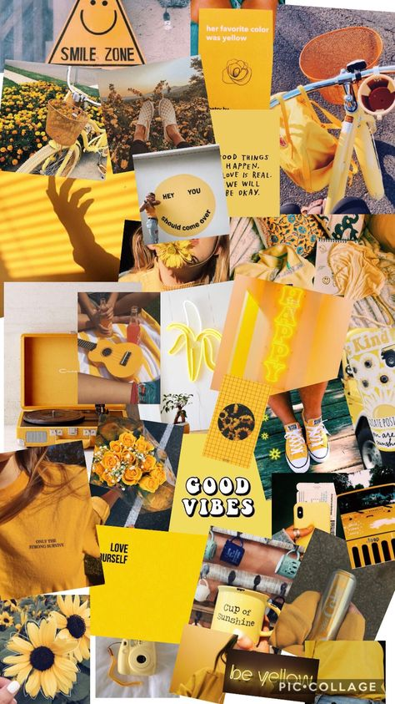

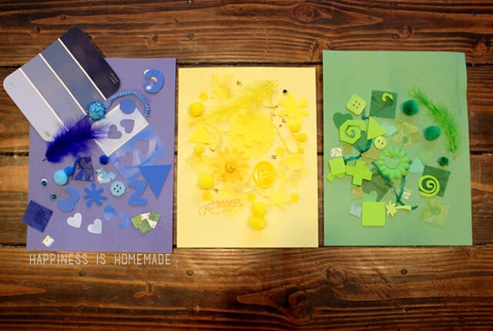

*What is your favorite color? I want you to go on a scavenger hunt! Look all around your home (inside and out, with permission) I would like you to collect as many items as you find that represents your favorite color. You might find, buttons, feathers, scraps of paper, stickers, wrappers, etc. You can use old magazines to look for pictures or items that match your color and cut them out. You can gather crayons and markers of the same color to add to drawing to your collage as well.

*Now that you have all of your items and collage materials gathered, begin to arrange them on your paper (or cardboard) how you would like them to look. Once you have them arranged, use glue or a glue stick to adhere your items to your paper. Once you have all of your items glued down, you can use that same color marker, crayon, colored pencil to add details to your collage!

*When you are finished and if you would like to CHALLENGE yourself, try to create a collage of many colors grouped together! This will give a rainbow effect! (You can see a photo example above).

*Please, share your collage creation with your family, friends or me! **CREATE and have FUN!**